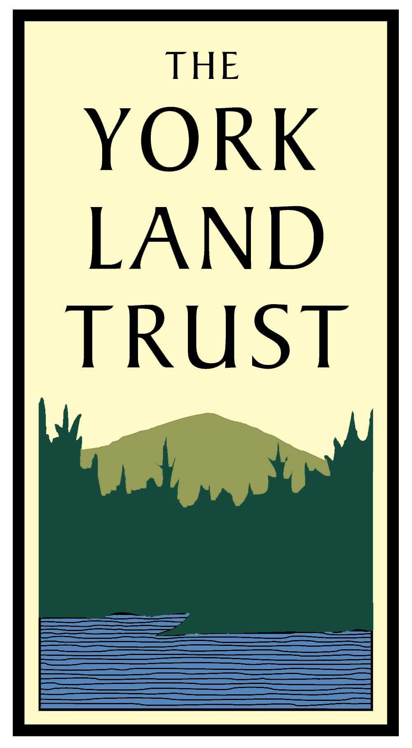
The York Land Trust
Instructions for Gifting Securities

- Contact your broker with York Land Trust’s securities gift instructions (below), making certain to record the date of your request. This date is the gift date used to calculate the value of your gift.

Edward Jones DTC Number: 0057

Edward Jones Routing Number: 071000152
YLT Account Number: 681-10908-1-7

- Once you have directed your broker to initiate a securities gift, kindly call Patty O’Connor, Development Assistant, at the York Land Trust (207.363.7400) with the transfer request date, stock information, and your contact information.

- York Land Trust staff will contact our broker (Susan Heckaman at Edward Jones) to alert her of your gift.

- Susan will receive your gift into York Land Trust’s account within 3-5 business days. Once your gift is received, Susan sells the stock.

- York Land Trust receives the proceeds, via a check from Edward Jones, for the stock’s sale.

- York Land Trust generates a formal thank you letter with a gift amount determined on the day you requested the stock transfer from your broker.

- Please contact Patty O’Connor with questions or to request additional information.

- York Land Trust Employer Identification Number: 22-2793161.

Patty O’Connor
Development Assistant
York Land Trust
1 Long Neck Marsh Road
York, ME 03909

Voice: 207.363.7400
E-mail: poconnor@yorklandtrust.org
Web: www.yorklandtrust.org

